Lab Assignment - 3

**MODULATION USING SIMULINK**

Name : Anuvind M P

Roll no: AM.EN.U4AIE22010

1. Build the Simulink model of AM modulator with parameters Carrier Signal frequency = 2*pi*25, Message Signal frequency = 2*pi and sampling time=1/5000. Amplitudes of both signals are 1

**BLOCK DIAGRAM :**

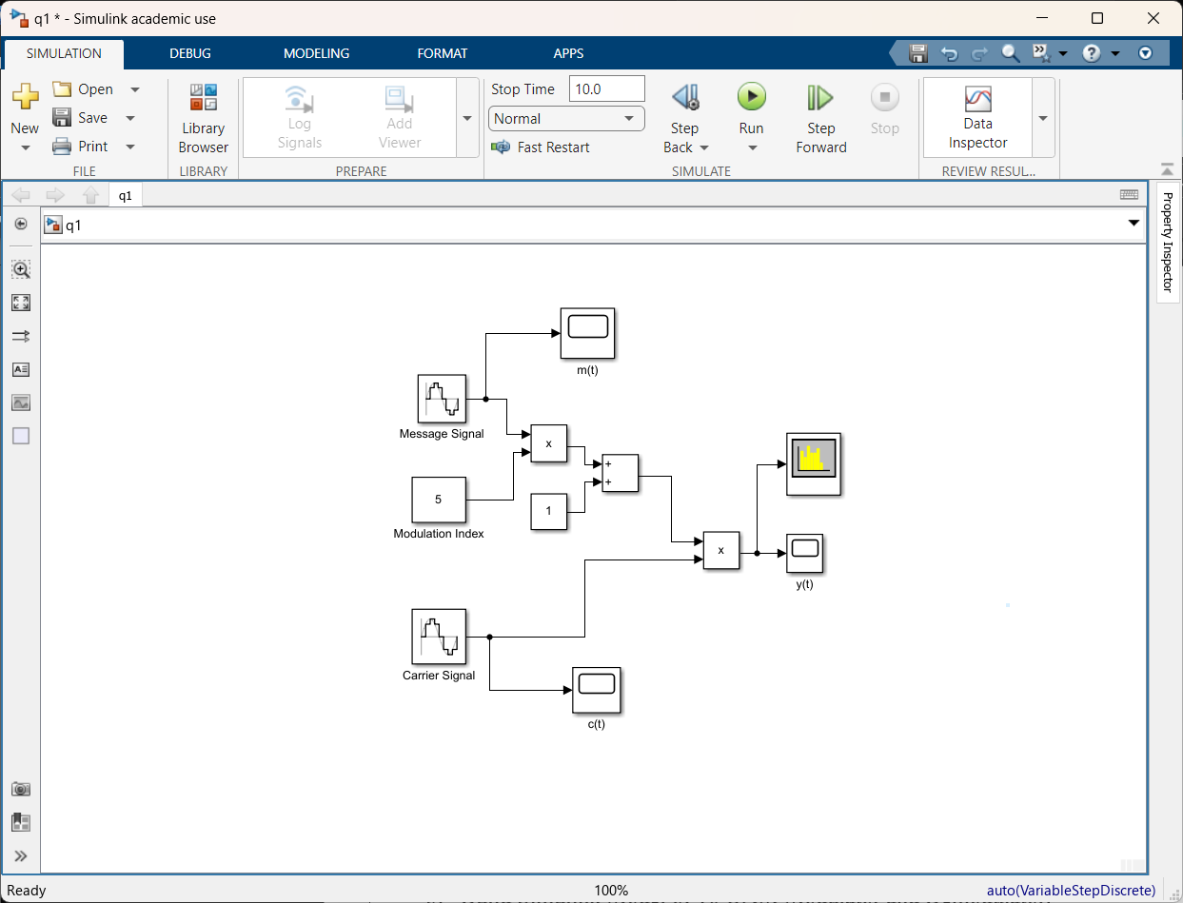

**Message signal :**

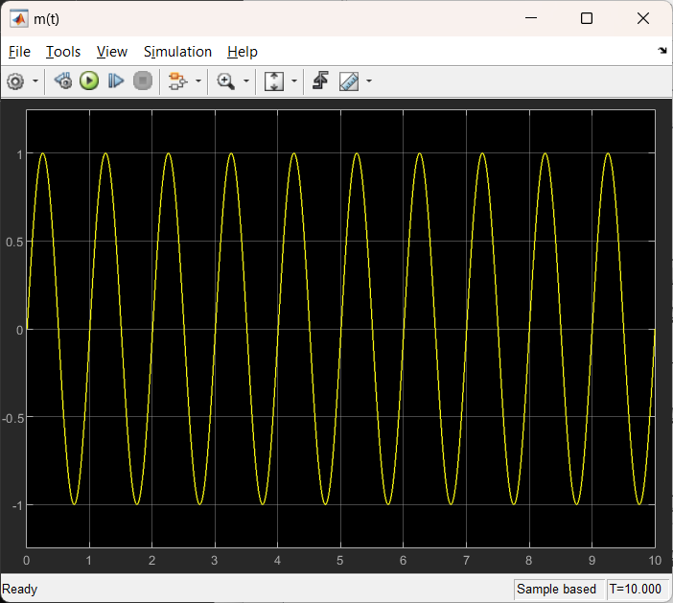

**Carrier signal :**

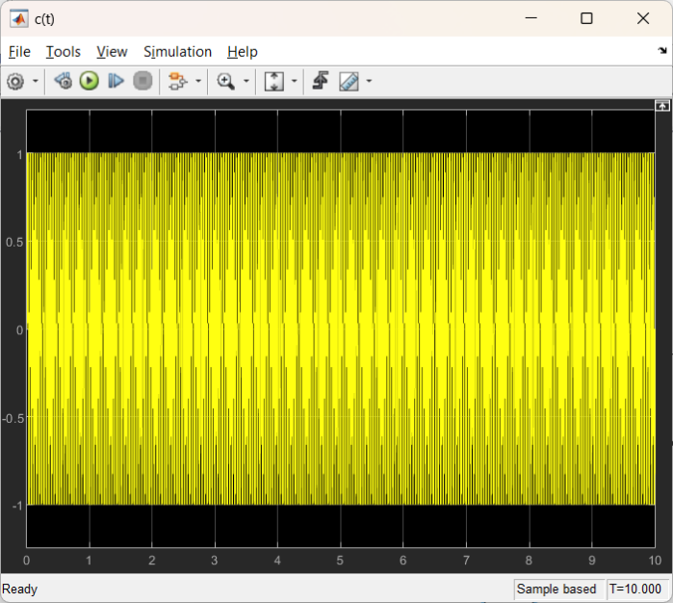**Frequency spectrum:**

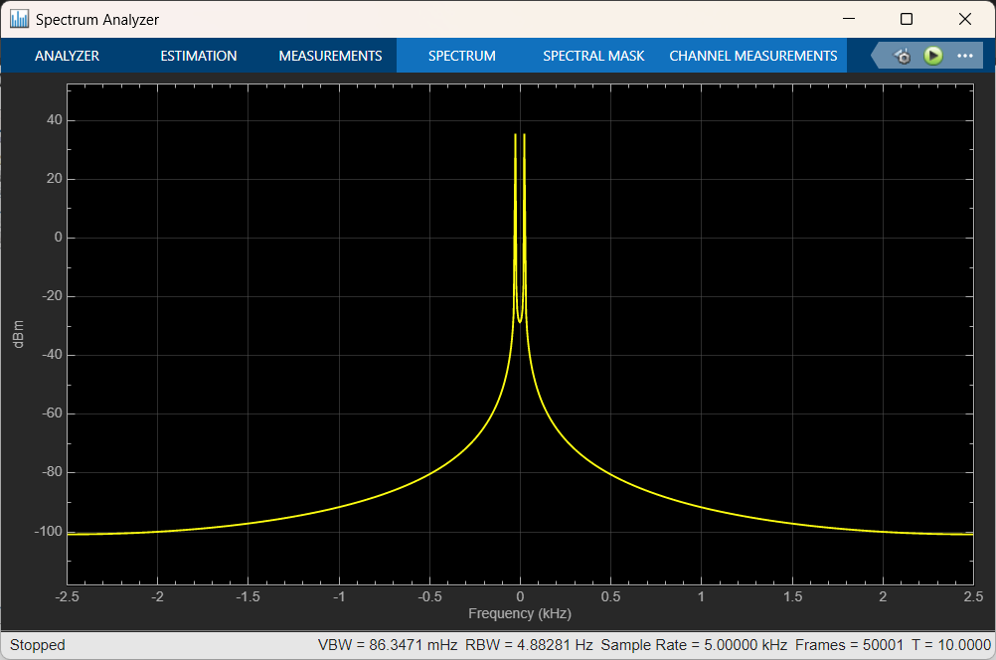

**AM modulated signal :**

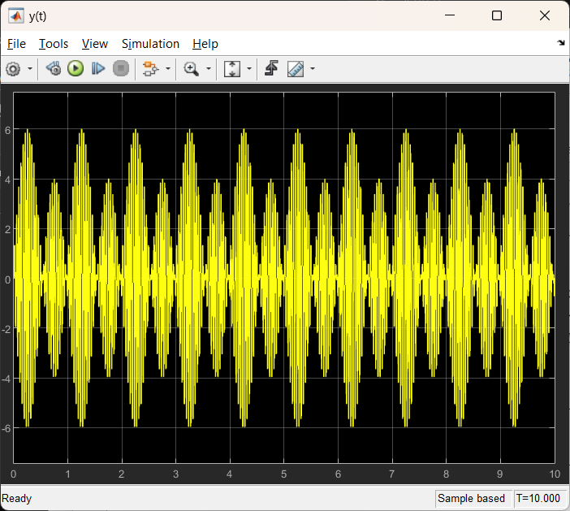

1. Build the Simulink model of FM modulator.

**BLOCK DIAGRAM :**

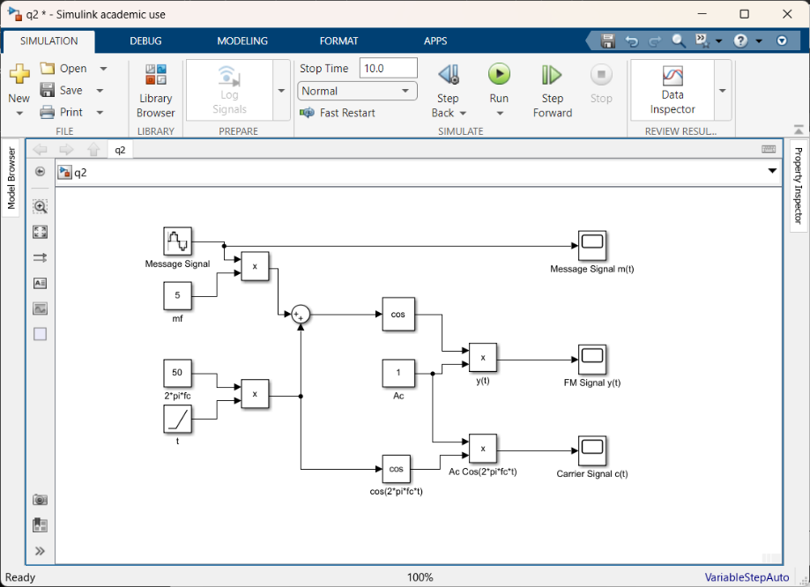

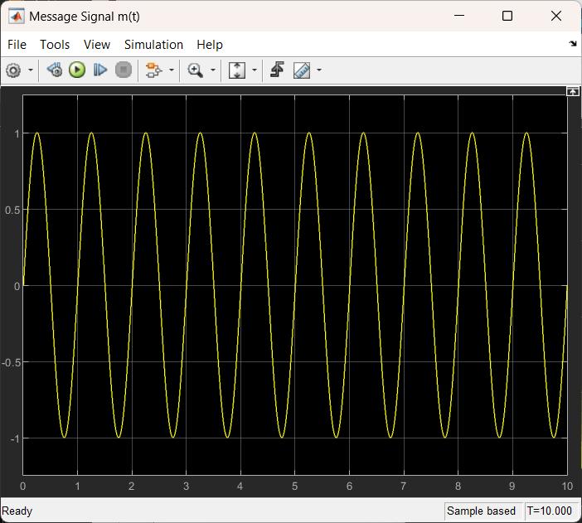**Message signal : Carrier Signal :**

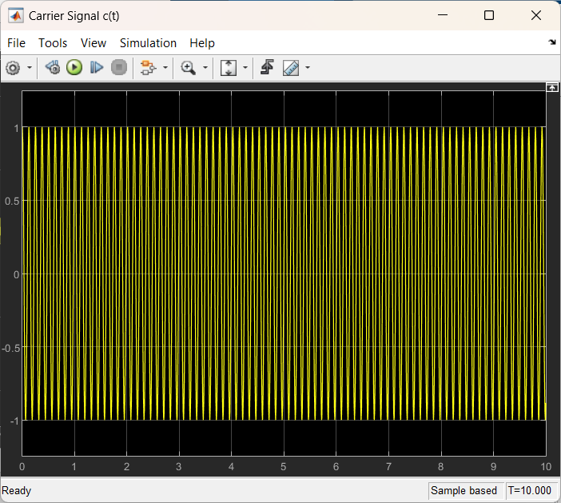

**FM modulated signal :**

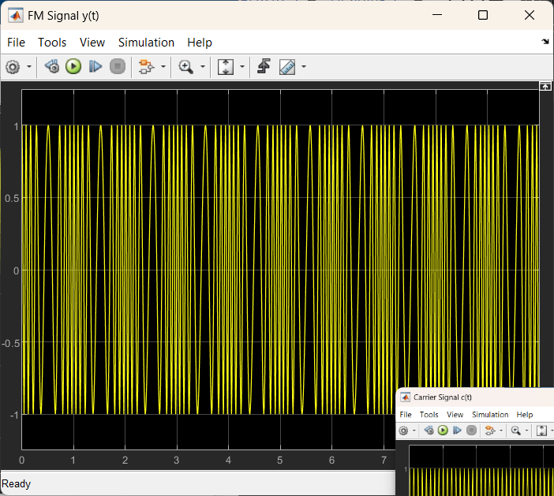

1. Build Simulink Model of 16 QAM Modulator and Demodulator.

**BLOCK DIAGRAM :**

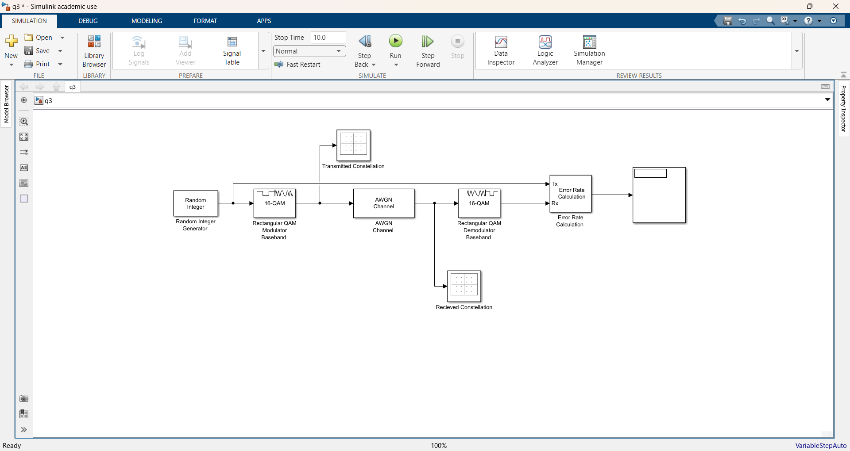

**Transmitted Constellation: Received Constellation:**

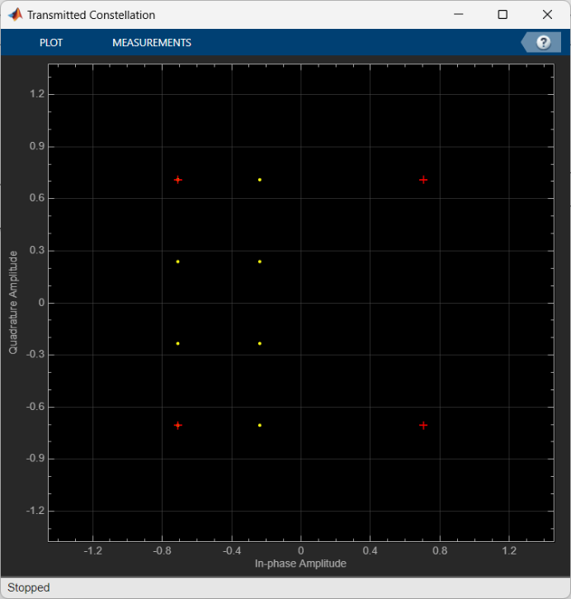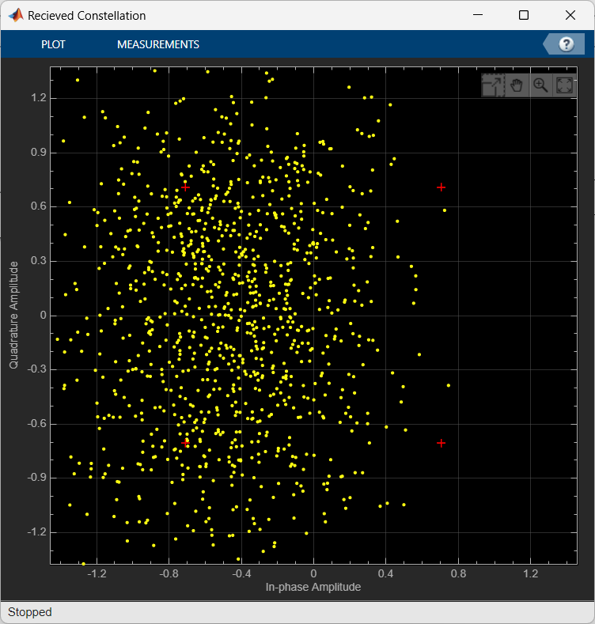

1. Try to simulate a music file transmission using 16 QAM modulation with AWGN channel

**BLOCK DIAGRAM :**

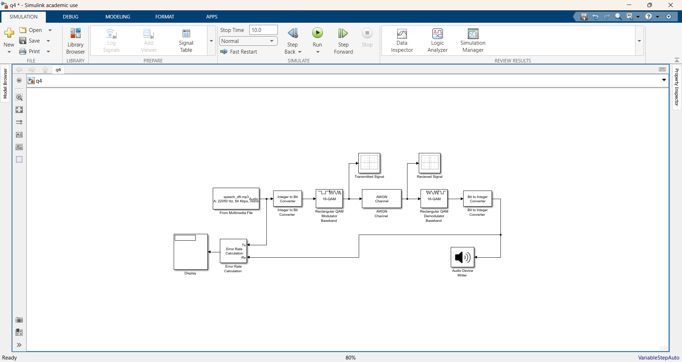

**Comments on Audio Quality:**

* **SNR = 10 dB (low)**: The audio quality is poor with significant noise and distortion. The music is recognizable but heavily affected by noise.
* **SNR = 50 dB(medium)**: The audio quality is good with slight noise. The music is clear and enjoyable, with minimal artifacts.
* **SNR = 100 dB(high)**: The audio quality is excellent. The music is very clear, with negligible noise, providing an experience close to the original audio.